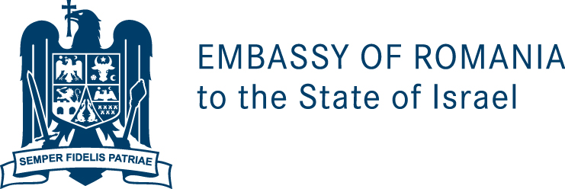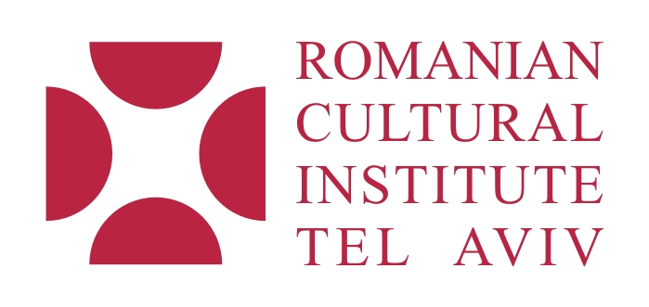

You are cordially invited
to a special Opera Recital in honor of

The National Day of Romania

Performed by:
Mirela Grădinaru, soprano – Israeli Opera, Tel Aviv
Fülöp Márton, bariton – Romanian National Opera Cluj-Napoca
Sorin Lupu, tenor – Romanian National Opera Bucharest

Accompaniment:

Mrs. Bella Steinbuk, piano – Israel

Mr. Vladimir Chernomordik, clarinet – Israel

Mr. Alexander Kotlar, violoncello – Israel

Mr. Vitaly Reminiuc, violin – Israel
On 1st of December 2011, at 20:00
Grand Hall, Givatayim Theatre
40 Remez Street, Givatayim

The Programe includes works by Giuseppe Verdi, Hector Berlioz, Gaetano Donizetti, Tiberiu Brediceanu, Enrico Canio, Eduardo di Capua.

The concert will be followed by a cocktail reception

RSVP and tickets reservation by November 22nd :
Tel: 03-696 17 46
E-mail: info@icrtelaviv.org

