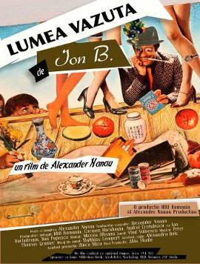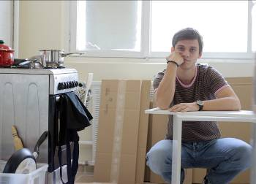

PRESS RELEASE

Romanian films and special guests at the Jerusalem Film Festival
July 8-17

The Romanian Cultural Institute in Tel Aviv has had, during the last years, an important contribution in the promotion of the new Romanian cinema to Israel, not only by presenting the best latest Romanian films at important Israeli festivales, but also bringing to Israel these films’ directors, actors, producers, to meet and discuss with the Israeli public and press.

“The first Romanian film in the Jerusalem Film Festival was presented in the summer of 1989.
Not just any film, but Reenactment” (Iulia Blaga, film critic). Reenactment (Romania, 1968) was named in 2008 the best Romanian movie of all times by the Romanian Movie Critics Association.
Since then, the best Romanian films have been screened in the Festival every year.

The latest productions of the new Romanian cinema will be presented at the 27th edition of the Jerusalem Film Festival, with the support of the Romanian Cultural Institute in Tel Aviv:
- the feature TUESDAY, AFTER CHRISTMAS (Romania 2010), directed by Radu Muntean
Screenings: July 10 (at 14:15) and July 12 (at 22:00)
99 minutes. Subtitles: Hebrew, English
- the documentary THE WORLD ACCORDING TO ION B. (Romania 2010), directed by Alexander Nanau
Screenings: July 9 (at 12:00) and July 10 (at 11:15)
61 minutes. Subtitles: English
After the screenings, Q&A with the Festival guests: Maria Popistaşu, leading actress, Tuesday, After Christmas, Alexandru Baciu, co-scriptwriter, Tuesday, After Christmas and Alexander Nanau, director, The World According to Ion B.

Also, in a special program, Short Matters – The European Film Academy Short Films Competition, 2009, the film “Renovation” (Germany/Romania 2009), directed by Paul Negoescu will be screened on July 9 and July 13 (24 minutes. Subtitles: English).

Tickets can be ordered online

About TUESDAY, AFTER CHRISTMAS
At JFF Radu Muntean presented his films, Boogie (2008) and The Paper will be Blue (2007). It was already clear then that this is a filmmaker who knows his craft. Now, he returns to the same social milieu as the previous film: Romania’s post-communist rising bourgeoisie. Although he has a clear critique of the new class represented by his protagonists, he chooses to go about it in subtle ways (and, as in Boogie, the male character is a lot less complex than the female ones). The romantic triangle has gotten its fair share of cinematic treatment, and Muntean decides to do his with a realistic approach, dictating the film’s style. He takes full advantage of the width of the screen and chooses actors who know how to express themselves naturally, both in words and in body language.
(source: http://www.jff.org.il/?CategoryID=750&ArticleID=918)

Trailer: http://www.youtube.com/watch?v=OCjgL0cEIxY

About THE WORLD ACCORDING TO ION B.
Ion Barladeanu is a homeless 62-year-old. The place he calls home is a filthy mattress in the garbage room of one of Bucharest’s apartment blocs. There, he lives in exchange for sorting through the landlords’ trash and in the meantime he collects books, newspapers, and magazines, and makes collages out of them. After hearing about Ion’s hobby, young gallery owner Dan Popescu discovered, to his amazement, 800 collages that Ion has made since the 1970s. Through his original collages, Ion managed to tell stories in a cinematic style and starring the great cinema stars of the era, whose pictures he cut out of the newspaper. Today, with the encouragement of Dan Popescu, Ion presents his works in galleries and museums in Romania and the world.
(source: http://www.jff.org.il/?CategoryID=756&ArticleID=838)

Trailer: http://www.youtube.com/watch?v=oMAidt6Wu8Q

About RENOVATION
Trailer: http://www.hifilm.ro/view_movie_details.php?id=46

