PRESS RELEASE

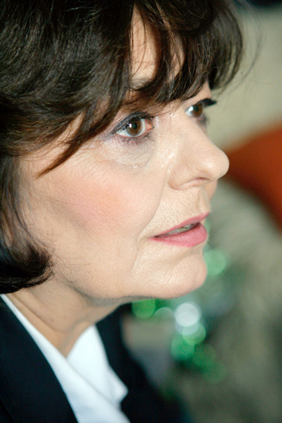

ANA BLANDIANA at the SHA'AR International Poetry Festival, Tel Aviv

A poem writes itself, it is not being written.
I do not write the poem, the poem writes itself in me, in my flesh.
(Ana Blandiana)

SHA'AR International Poetry Festival will take place between the 21st and the 23rd of October 2010. Among the festival's guests is the Romanian poetess Ana Blandiana, already known by the Israeli readers because of her book "Happiness always hurts someone", a joint translation into Hebrew by Moshe Granot and Shaul Carmel, published by Keshev Publishing House.
Ana Blandiana's presence at SHA'AR is supported by the Romanian Cultural Institute in Tel Aviv.

SHA'AR International Poetry Festival is an interdisciplinary poetry festival which hosts established Israeli and guest poets, as well as young promising poets and artists.
SHA'AR involves the public in the dialogue, including multi-media Arabic and Hebrew works and a wide variety of activities. Besides poetry readings a panel discussion and meetings with editors of poetry journals, the festival presents collaborations of poetry with other artistic fields: music, dance, visual arts, theatre.

Ana Blandiana has published 14 collections of poetry, two collections of short stories, one novel and five collections of essays. Her works were banned in Romania three times: 1959-1964, 1985 and 1988-1989.
Her poems have been translated into 23 languages, including Hebrew. Ana Blandiana has received many international prizes for her works, among which Herder Prize (1982), the prize of the Vilenica International Literature Festival (Slovenia, 2002) and Premio Internazionale Camaiore (2004).

Ana Blandiana's poetry readings, as follows:
Thursday, 21.10.2010 | 20:00 | The Arab-Hebrew Theatre | 10 Mifratz Shlomo St, Old Jaffa
Saturday, 23.10.2010 | 22:00 | The Arab-Hebrew Theatre | 10 Mifratz Shlomo St, Old Jaffa

Details: www.icr.ro/tel-aviv/ www.helicon.org.il www.arab-hebrew-theatre.org.il

