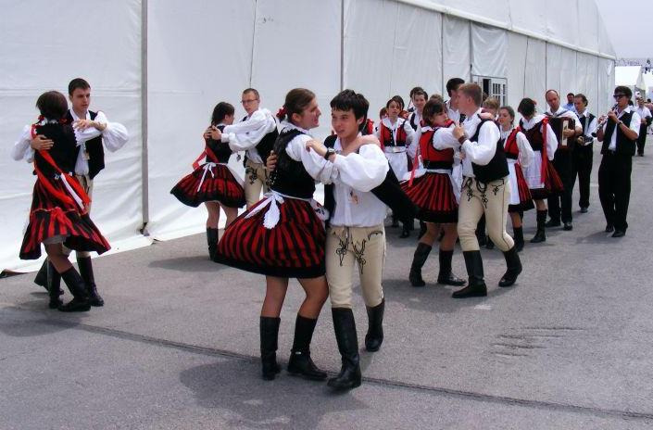

PRESS RELEASE

With the support of the Romanian Cultural Institute in Tel Aviv and the Department for Inter-ethnic Relations, Romanian Government, the traditional dance group „Albăstrița/Búzavirág/Cornflower” from Braşov participates in the Karmiel International Dance Festival in northern Galilee, Israel, presenting traditional Romanian and Hungarian dances from Ţara Bârsei region, in colourful costumes of the two ethnic comunities.

The 2011 Festival takes place between July 12-14 in various sites in and around Karmiel (the big amphitheatre; Baruch Center – Cornflower performance, July 12, starting 23:55 -, on the streets of Karmiel etc).

3 days and nights, with over 80 performances and events, and the participation of over 5,000 dancers - worldwide, with over 300,000 visitors that will paint the green Galilee city of Karmiel with a rainbow of colors, dance and rhythm. Looking forward to seeing you there!
Complete festival program, more information: http://www.karmielfestival.co.il/, www.icr.ro/albastrita_en

