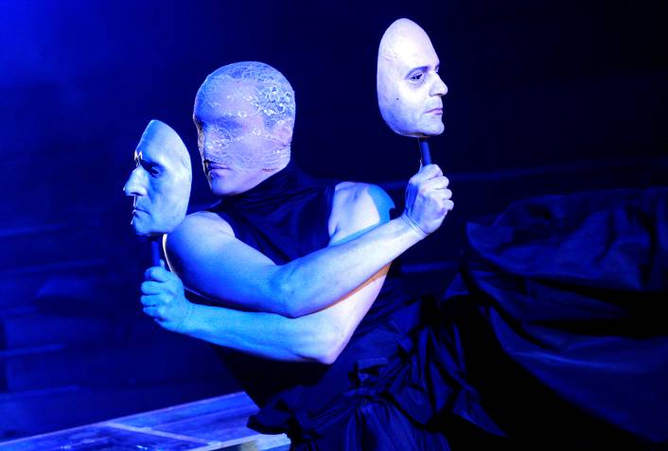 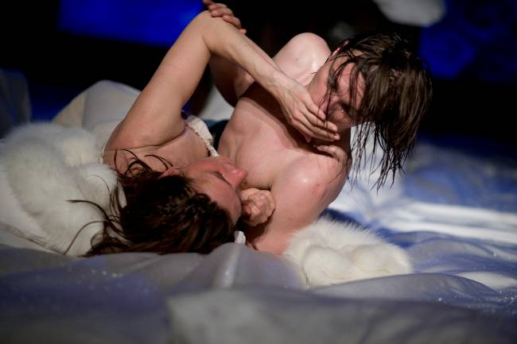 Photo from the performance Iulius Caesar, dir. by Alexander Hausvater Photo from the performance Love Thyself, by Maria Manolescu
National Theatre in Timişoara, 2010 dir. by Radu Apostol, Foarte Mic Theatre, Bucharest, 2010
© George Enache

PRESS RELEASE
ROMANIAN THEATRE TODAY. A week of study and experiment
Tel Aviv University, Department of Theatre Arts, 3-8 April 2011

The Romanian Cultural Institute in Tel Aviv, in partnership with the Tel Aviv University, Department of Theatre Arts, organize in the beginning of April a joint event celebrating and promoting Romanian contemporary theatre and aiming to create new professional contacts and partnerships in the theatric field, between Romania and Israel.

The project is constructed on three kinds of cultural events: a 6-day masterclass (by celebrated director Alexander Hausvater), conferences on Romanian drama and theatre (by Cristina Modreanu) and staged readings from contemporary Romanian plays in Hebrew translation (Gianina Cărbunariu - Stop the Tempo!, Vera Ion - Vitamins, Maria Manolescu - Love Thyself). Saviana Stănescu's play Aliens with Extraordinary Skills will also be distributed to the students and other theatre and academic professionals.

Theater has always been an essential part of the Romanian culture, but its role changed completely after the 1989 Revolution and the fall of the communist regime – says Cristina Modreanu, artistic director and sole selector of the National Theatre Festival in Bucharest between 2008-2010. Before that moment, theater and culture in general, were one of the ways people could experience freedom, in spite the oppressive political context. Legends were born those days, actors and directors who used the opportunity of being on stage for expressing what everyone was thinking and never dare to say upfront became iconic figures of Romanian society. In the same time, famous artists left the country and started their career in other cultures. Some of them were to come back after 1989 and actively contribute to completely restart the theater movement in their home country – Vlad Mugur, Radu Penciulescu, David Esrig, Alexander Hausvater, Andrei Serban.
After the confusion of this “zero point”, Romanian theater opened up towards the world, touring a lot in the early 90’s and trying to reconnect with Western cultures. But it’s only after 2000 that a new generation of theater creators was really born. Their voices – Radu Afrim, Gianina Carbunariu, Vlad Massaci, Alexandra Badea and others - are now the most interesting to hear on Romanian stages and not only there. In a new globalized context, they all travel to present their work in other countries or even create in different cultural contexts, where they bring their Romanian heritage.
Together with other new tendencies that can be detected in the past years, like the use of different performing spaces, the new voices in drama, the social oriented work of independent companies and the interdisciplinary projects – they define what it is to be the present of Romanian theater, also giving a clue about how its future can look alike.

Having a long and the rich tradition, after the fall of the communism the Romanian theatre went through a hectic but powerful journey, becoming a real stage for experimentation an gaining an important place worldwide, says Gina Pană, director of the Romanian Cultural Institute in Tel Aviv. The students and professors at the Tel Aviv University, as well as the general public, may now enjoy an excellent possibility to connect themselves with and experiment the contemporary Romanian theatre.

Free entrance. The events take place in Hebrew and English.
The daily schedule, more information: http://www.icr.ro/teatrul_romanesc_azi

