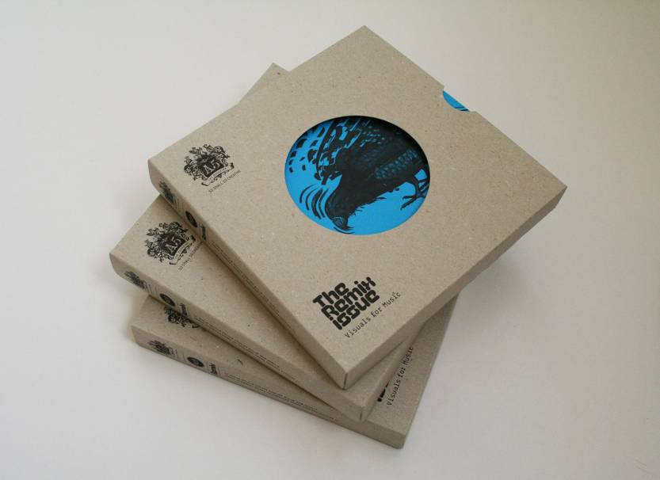

PRESS RELEASE

A5 Magazine – Launching event of the special issue, REMIX, in collaboration with the Romanian Cultural Institute (ICR) in Tel Aviv

Works signed by 20 Romanian artists and authors appear in the latest issue, the ninth, of the Israeli A5 Magazine, a publication focused on contemporary art and culture (www.thea5magazine.com), presented in a special format: 82 square post cards and titled REMIX.
The magazine features 77 Israeli and international artists and authors, among which the 20 Romanian ones: Andreea Anghel, Vlad Andrei Gherghiceanu & Nicu Ilfoveanu, Maxim Dumitraş, Vasile Raţă, Andra Rotaru, Ioana Milea, Loriana Marchetanu, Claudiu Ciobanu, Oana Bolog-Bleich, Renee Renard, Saviana Stănescu, Levente Kozma, Daniela Frumuşeanu, Otilia Cadar, Dan Sociu, Rodica Toth Poiată, Simona Vilău, Florica Prevenda, Corina Raiciu, Elena Vlădăreanu.
The works have been selected following a call for submissions launched by ICR Tel Aviv and A5 Magazine in the summer of 2009.
The REMIX issue lanching event is taking place on January 6, starting 20:30, at Saloona club in Jaffa. There will be special screenings of video and animation clips, created specially for this event, in collaboration with musicians and digital media artists, and also live performances - Anat Segal, songs from her latest album “Petach”, DJ Erez Zuk-Ramon and Udi Sharabani.

