MAGDA CARNECI

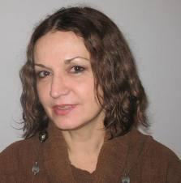

Magda Carneci is a Romanian-born writer, cultural journalist, and art critic.
Member and theoretician of the famous “generation of the eighties” in Romania, starting with the Revolution of December 1989 she was involved in the political and cultural Romanian scene of the 1990s. Already in 1989, she signed together with other 15 young writers a letter of protest against the Romanian communist regime. In December 1989 – January 1990 she was a member of the Front of National Salvation. At the same time, she was also a founding member of the Group for Social Dialog (GDS), the first free NGO in Romania, composed of well-known intellectuals, some of them dissidents or opponents of the Ceausescu regime.

Magda Carneci was the director of the Institute of Art History in Bucharest (1990-1992), president of the Group for Social Dialog (1992-1993), president of the board of the Soros Center for Contemporary Art in Bucharest (1998-2002). From 2007 until 2010 she was the director of the Romanian Cultural Institute in Paris. At present, she is again president of the Group for Social Dialog and associate professor at the National University of Arts in Bucharest.

Magda Carneci took her Ph.D. in art history at the EHESS (Ecole des Hautes Etudes en Sciences Sociales) in Paris in 1997. Among other books, she published Art et pouvoir en Roumanie 1945-1989 (Art and Power in Romania 1945-1989, Paris, L’Harmattan, 2007). She was also the co-editor of the collective book Perspectives roumaines. Du post-communisme à l’intégration européenne (Romanian Perspectives. From Postcommunism to European Integration, Paris, L’Harmattan, 2004).

Member of the European Cultural Parliament and other international associations, she is often invited at international symposiums and debates about Central East Europe and European culture.

