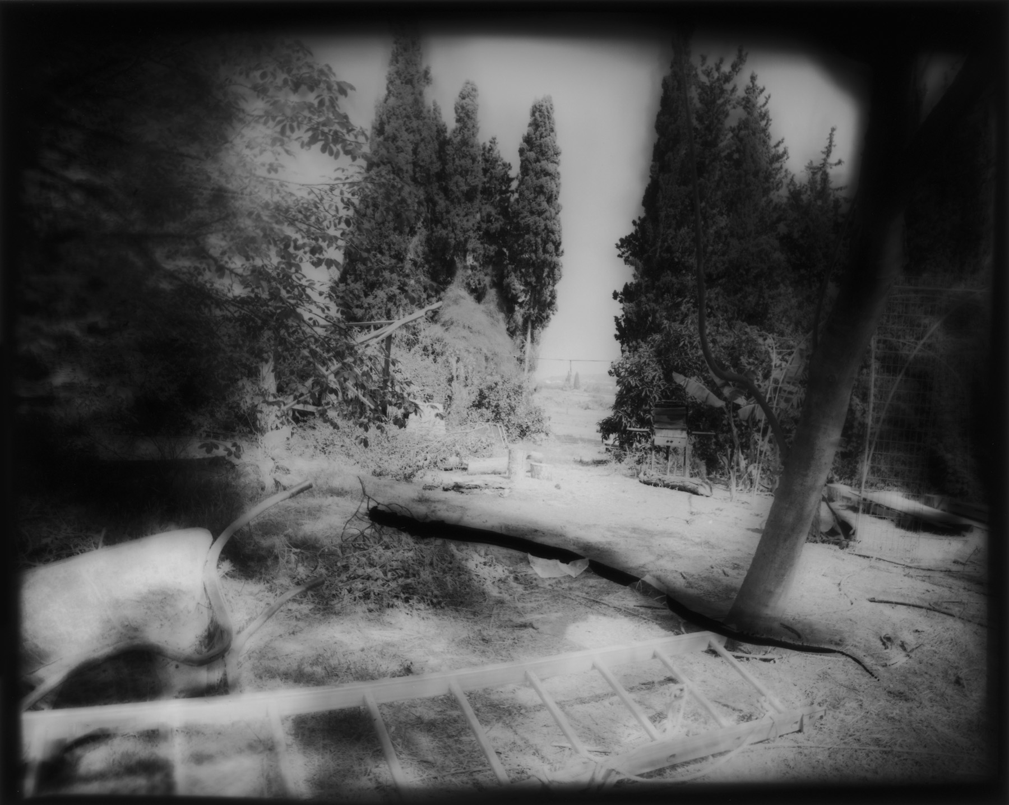 | 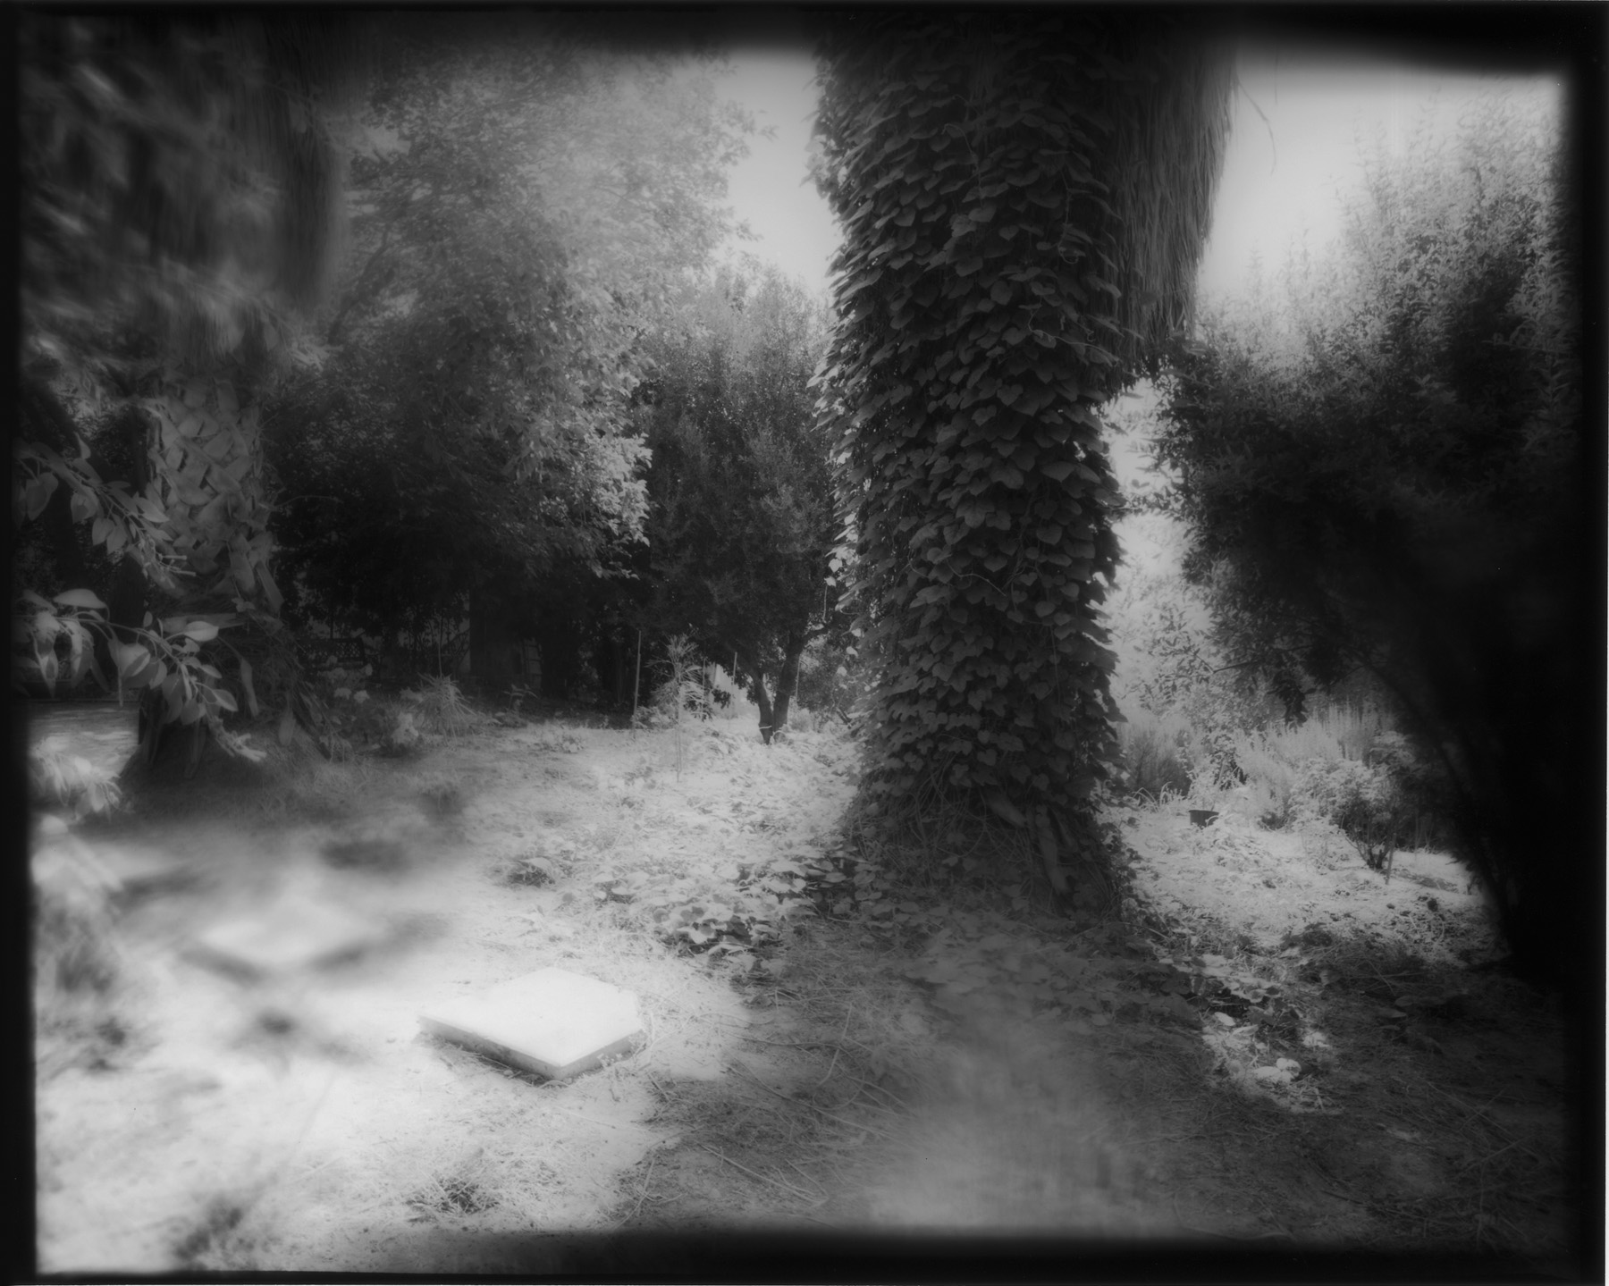

COMUNICAT DE PRESĂ

DUNAM
Expoziţie de fotografie a artistei Yehudit Matzkel

Institutul Cultural Român din Tel Aviv vă invită, în data de 27 august 2009, orele 18:00, la vernisajul expoziţiei DUNAM , aparţinând artistei israeliene de origine română Yehudit Matzkel.

Născută în 1952 în România, Yehudith Matzkel a studiat artele plastice şi fotografia la Facultatea de Artă a Universităţii din Tel Aviv, la Institutul de Artă Bat Yam şi la Beit Berl College, Kfar Saba.
A deschis numeroase expoziţii personale în muzee şi galerii din Israel, în colaborare cu prestigioşi curatori, a participat la expoziţii internaţionale de grup/colective, iar lucrările sale pot fi întâlnite în colecţii private sau publice din Israel şi din alte ţări. Până acum, creaţia artistei Yehudit Matzkel nu a fost cunoscută în România.

DUNAM propune o selecţie din creaţia mai recentă a artistei, o retrospectivă a ultimilor zece ani din activitatea sa. Lucrările propun o serie de imagini din natură, aproape neatinsă de prezenţa omului, un dialog paşnic, o simbioză între natură şi obiectele retrase din civilizaţia umană în grădină.

Expoziţia va fi deschisă în perioada 27 august-30 septembrie, de luni până vineri, între orele 10:00 – 15:00, la sediul Institutului Cultural Român din Tel Aviv, B-dul Shaul Hamelech nr.8, etaj 6.

www.icr.ro/tel-aviv/

YEHUDIT MATZKEL

P.O.B. 549
Nes Tsiona 75105, Israel
Phone: 972 (0)89406607
Mobile: 972 (0)252506752
E Mail : mazkl@netvision.net.il

Born in Romania (1951), lives and works in Kfar Aharon, Israel

Education:

1973–1974 Bat Yam Institute of Art
1974–1981 Faculty of the Arts, Tel Aviv University
1995–1998 Department of Photography, Hamidrasha School of Art, Beit Berl
College, Kfar Saba

Selected Solo Exhibitions:

2008
"The Primal Scream" ' Sadnot haomanim, tel aviv. ( catalogue)
2006
"Half a Dunam," The Artists House, Tel Aviv (catalogue)
2005
"The Tree of Knowledge," Ein Harod Art Museum
"Private Property," Tova Osman Gallery, Tel Aviv
2004
"The Tree of Knowledge," Herzliya Museum of Contemporary Art (catalogue)
2003
"Private Property," The Museum of Israeli Art, Ramat Gan (catalogue)
2002
"Untitled," The Gallery for Contemporary Art, Nes Tsiona (catalogue)
2001
"Provocative Things Never Exposed," WIZO College Gallery, Haifa
"Four x Four," Arad Museum
"Four x Four," Ashdod Museum of Art and the Museum of the Shefelah, Kfar Menachem
2000
"Skirt on the Way" – Three Years with Givati, Migdal Gallery, Eretz Israel Museum, Tel Aviv (catalogue)
"Deep," Kibbutz Cabri Gallery
1999
"The Naked Grove," Eretz Israel Museum in collaboration with the Municipal Gallery, Rehovot and the Rishon LeZion Arts Center
"Stillborn," The Museum of Israeli Art, Ramat Gan
1998
"A Soldier's Mother," Janco Dada Museum, Ein Hod (catalogue)
1995
"God Doesn't Count Women's Tears," Kidmat Eden Contemporary Art Gallery, Tel Aviv
1992
"Matter – Environment," The Studio on Borochov, Tel Aviv
1990
"The House in Nes Tsiona," Amalia Arbel Art Gallery, Rishon LeZion

Selected Group Exhibitions:

2008
"The palm tree in Israeli art", Danon Gallery , Tel – Aviv
"NOWHERE" Pyramida, Haifa. Curator: Avraham Eilat
"Mirror' Mirror", Tova Ossman Gallery Tel Aviv
"Secondary nature", Municipal Gallery Rehovot (catalogue)
2006
"Japan is Here," The Israel Museum, Jerusalem
2005
Israel Art Exhibition for the War on AIDS – Bank Hapoalim, Tel Aviv
Group exhibition, Herzliya Pituach
2004
Exhibition of Works from the Permanent Collection, The Museum of Israeli Art, Ramat Gan.
"In Your Dreams," Grindeg Gallery, Herzliya Pituach
"Women as Healers," Musrara Art Gallery, Jerusalem
"Pet Garden," Commemoration Center Gallery, Kiryat Tivon
"Pet Garden," Kibbutz Nachshon Gallery
"Hot Shot," Ben Gurion University Art Gallery, Be'er Sheva (catalogue)
"The Ashkenazis," Hamidrasha Gallery, Tel Aviv
"Love Hill," National Lottery Community Center, Nes Tsiona
2003
"Utopia," Gefen House, Haifa
"Every Day, Every Year" – the 30th Anniversary of the Yom Kippur War" Commemoration Center Gallery, Kiryat Tivon
Group exhibition, Ashdod Museum, Arad Museum, Kfar Saba Municipal Gallery
"The Art of Aging," Hebrew Union College Gallery, New York
2002
Salon-Gallerie de la Cité Internationale des Arts de la Photo – Paris
"Nature Twice Revealed," Hashefela Museum, Kfar Menachem
Exhibition in honor of International Day for the Elimination of Violence Against Women, Kastra Gallery, Haifa
Artist's Studio Gallery, Hadera
Bar David Gallery, Kibbutz Baram
2001
Group exhibition, New Workshop, Ramat Eliyahu, Rishon LeZion
"Peace and Coexistence," Bar David Museum, Kibbutz Baram
2000
"The Third Color," Artists House, Jerusalem (catalogue)
"Childhood," Gefen House, Haifa
1999
"Innocence," Gefen House, Haifa (catalogue)
1998
"Women in Reality," Limbus Gallery, Tel Aviv
"Flag – Nation – Flag," Pyramid Center for Contemporary Art, Haifa (catalogue)
"Serial Number," Commemoration Center Gallery, Kiryat Tivon; Municipal Gallery, Rehovot
"The Photographer's Child," Ramat Eliyahu Art Workshop, Rishon Lezion
1997
"Hair," Artists House, Jerusalem (catalogue)
"Miniature," Umbria Museum, Italy
1996
Group exhibition, Artfocus, Mishkenot Sha'ananim, Jerusalem
"Time for Women," Artists House, Haifa
"Healing the Schism No. 2," Yadayim Gallery, Jaffa
"Artists Sending Out Peace," Eretz Israel Museum (book)
"Portrait," traveling exhibition
1994
"Photography Between Art and Documentation," Kfar Saba Municipal Museum, Artfocus (catalogue)

Publications:

Theory and Criticism, no. 25, Van Lir Institute, Jerusalem (Hebrew)
Eran Akerman, "Private Property," Contact no. 65, October 2003 (Hebrew)
Tamar El-Or, Theory and Criticism no. 19, Van Lir Institute, Jerusalem (Hebrew)
Ito Aviram, "Givati – One of a Kind," Ministry of Defense Publications, 1999
Terminal no. 18, Winter 2002
Noga, Winter 2004
Studio Art Magazine, February 2002
Ruach Aheret, no. 6
Israeli Architecture, no. 37, article on "The Naked Grove"

Collections:

The Museum of Israeli Art, Ramat Gan

The Janco Dada Museum, Ein Hod
The Photography Museum at the Tel Hai Industrial Park
The Nes Tsiona Municipality
The Israeli Port Authority
Collections of the IDF Spokesperson, IDF Chief of Staff and the General of the Southern Command
The Museum at Mezudat Yoav

Yehudit Matzkel's works also appear in a private and public collections in Israel and abroad.

Scholarships and Prizes:
Residency at the Cité Internationale des Arts, Paris, in collaboration with the Israeli Ministry of Culture, Science and Sport (2002)

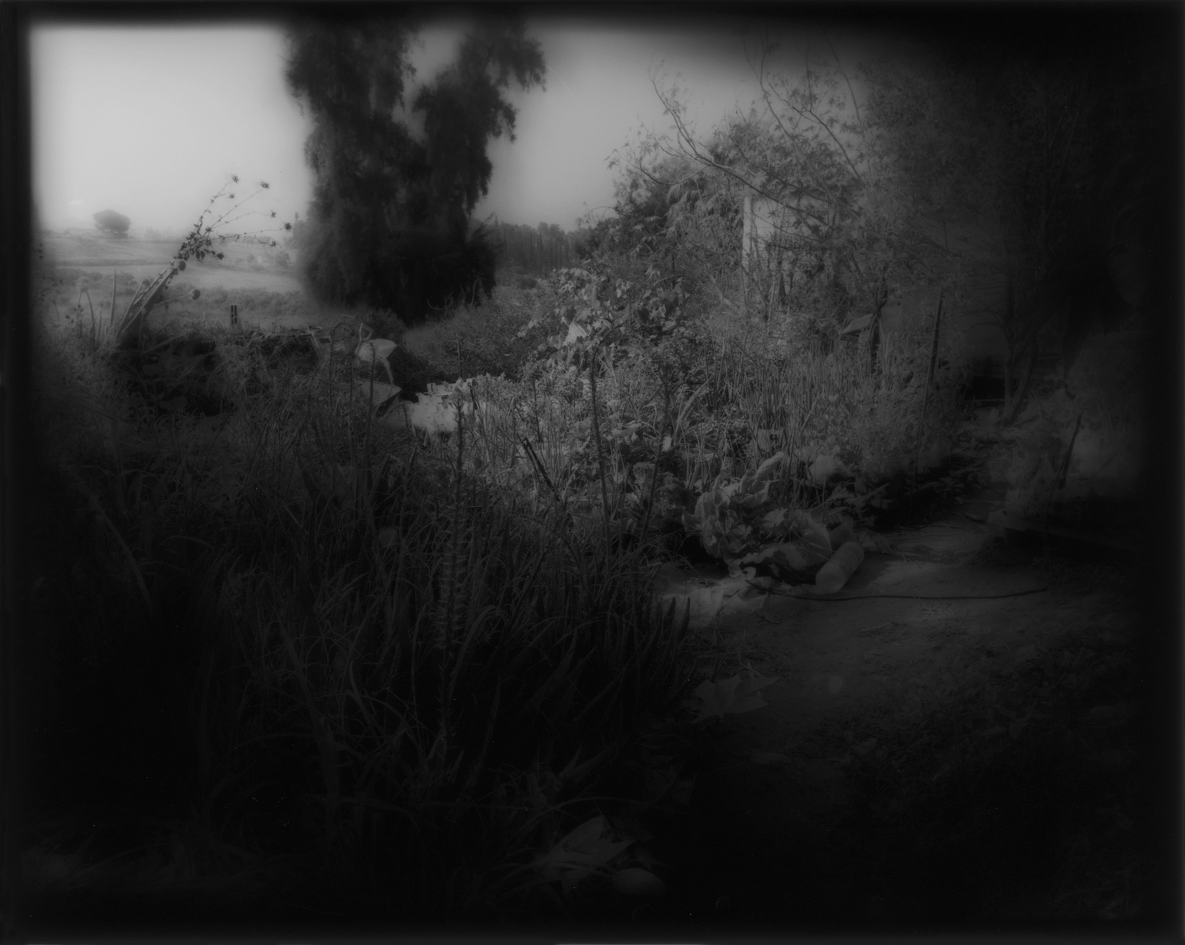 | 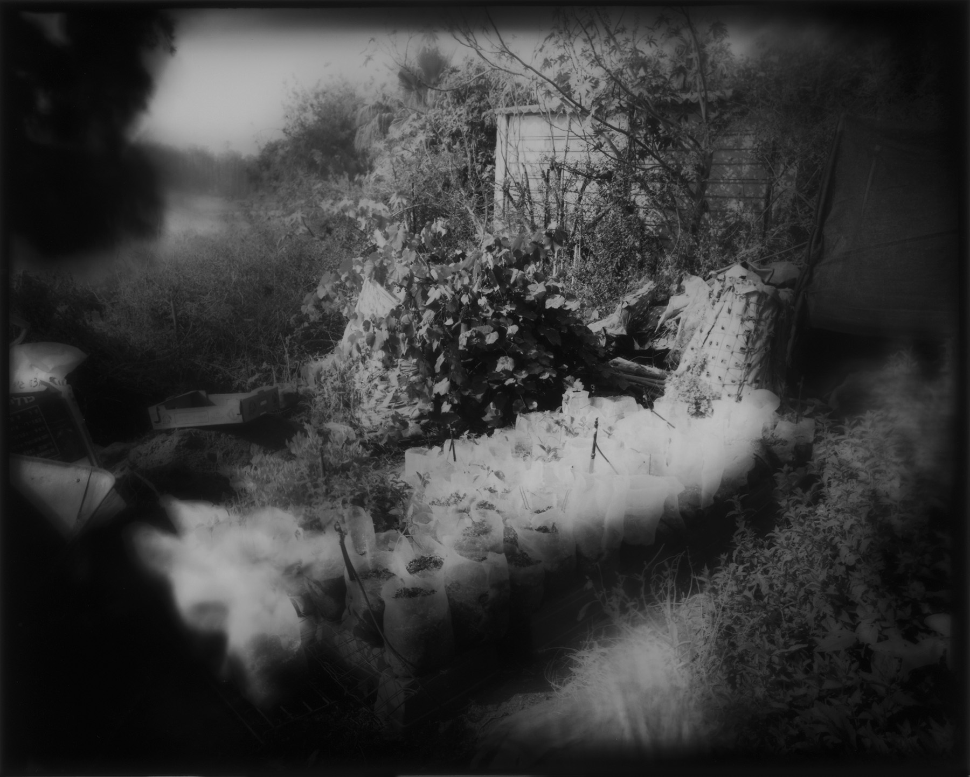
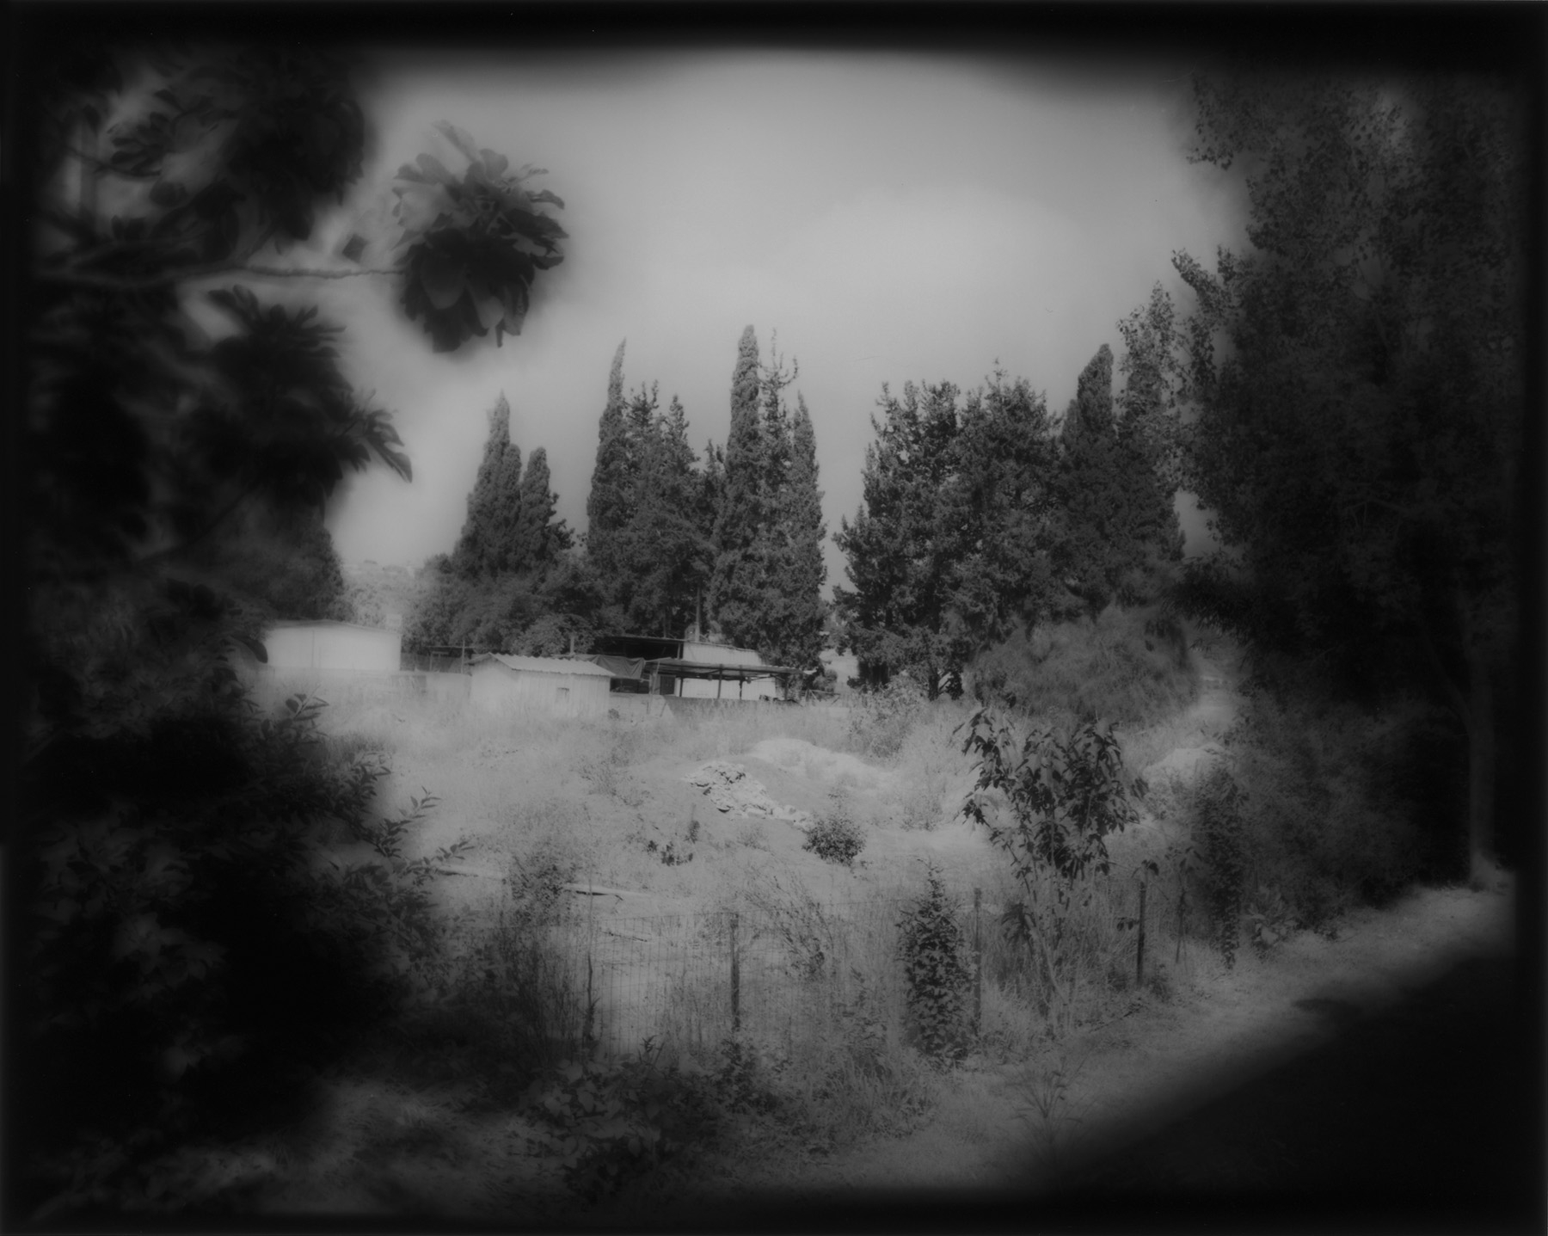 | 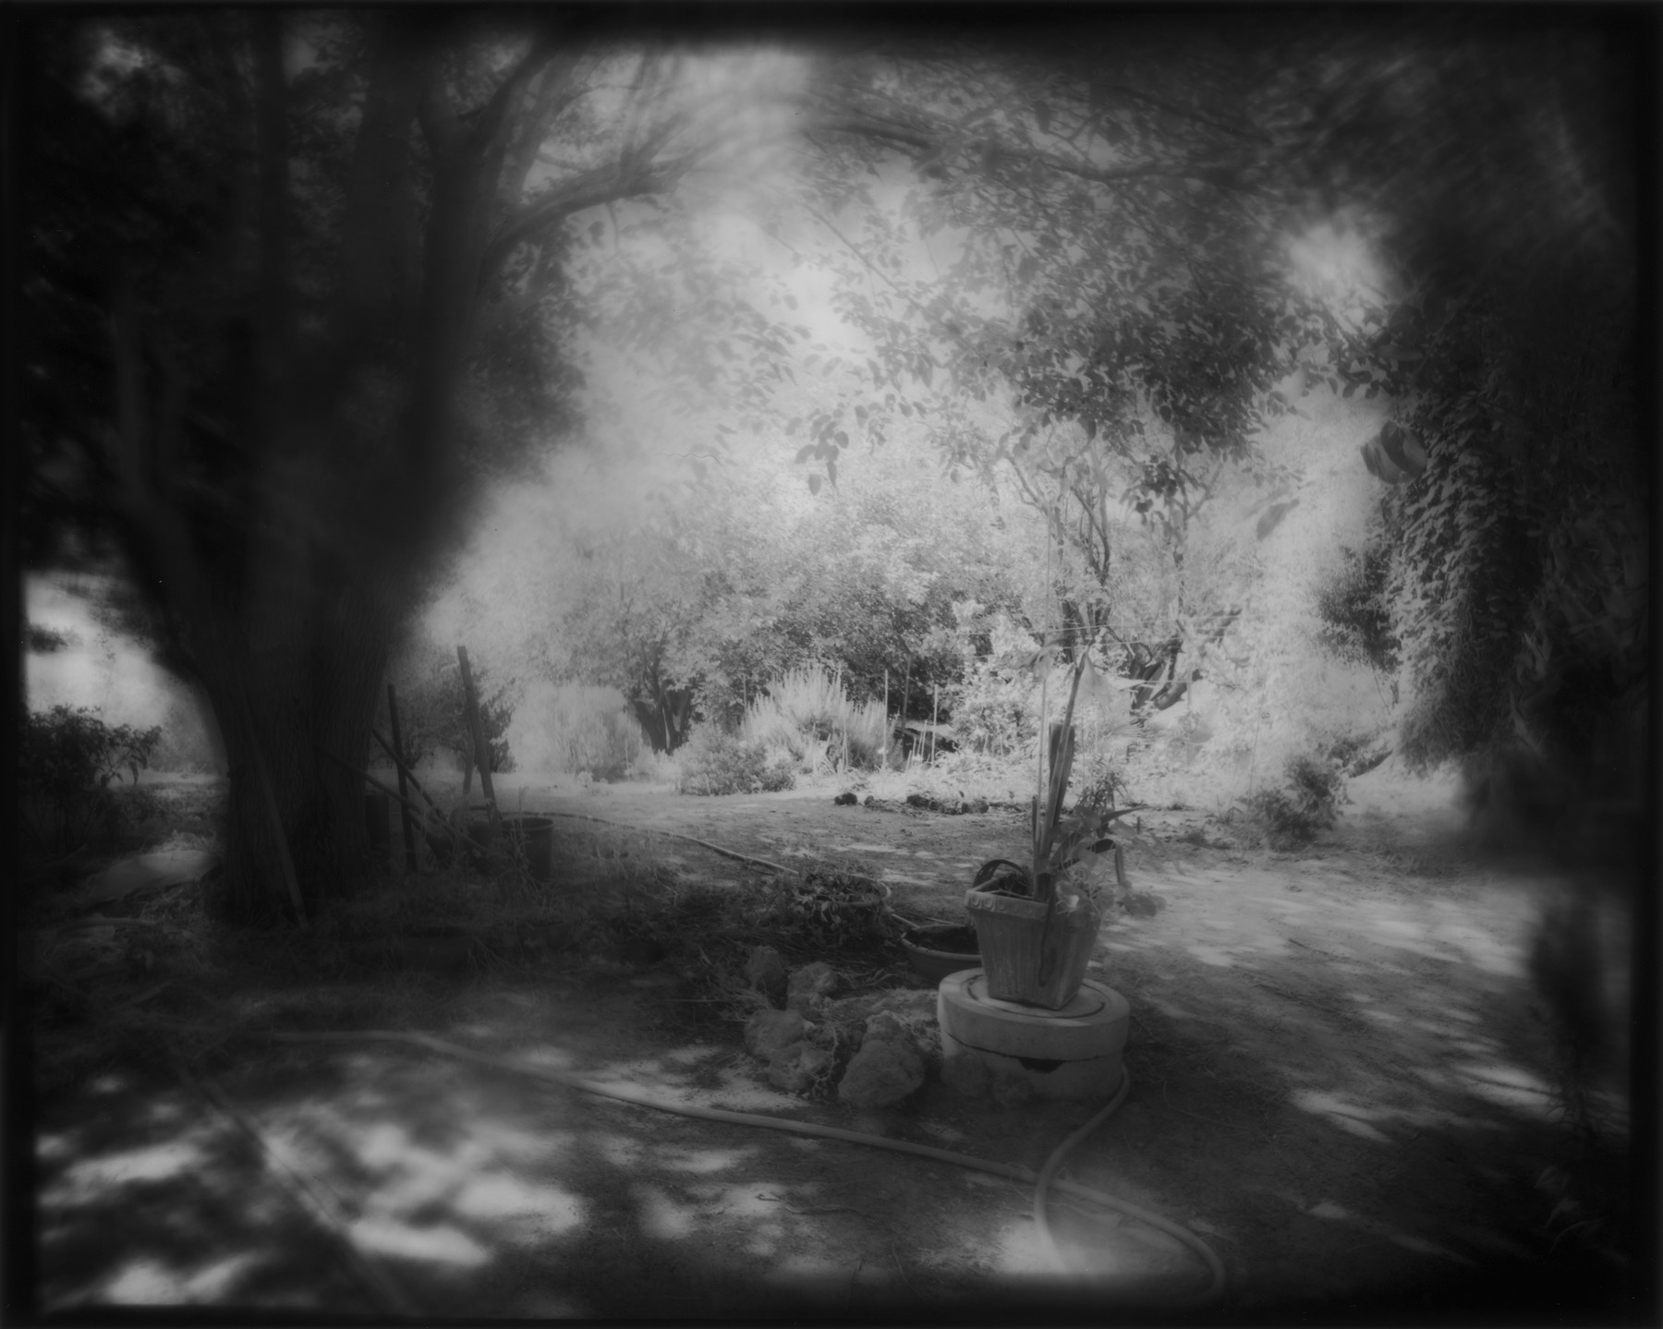
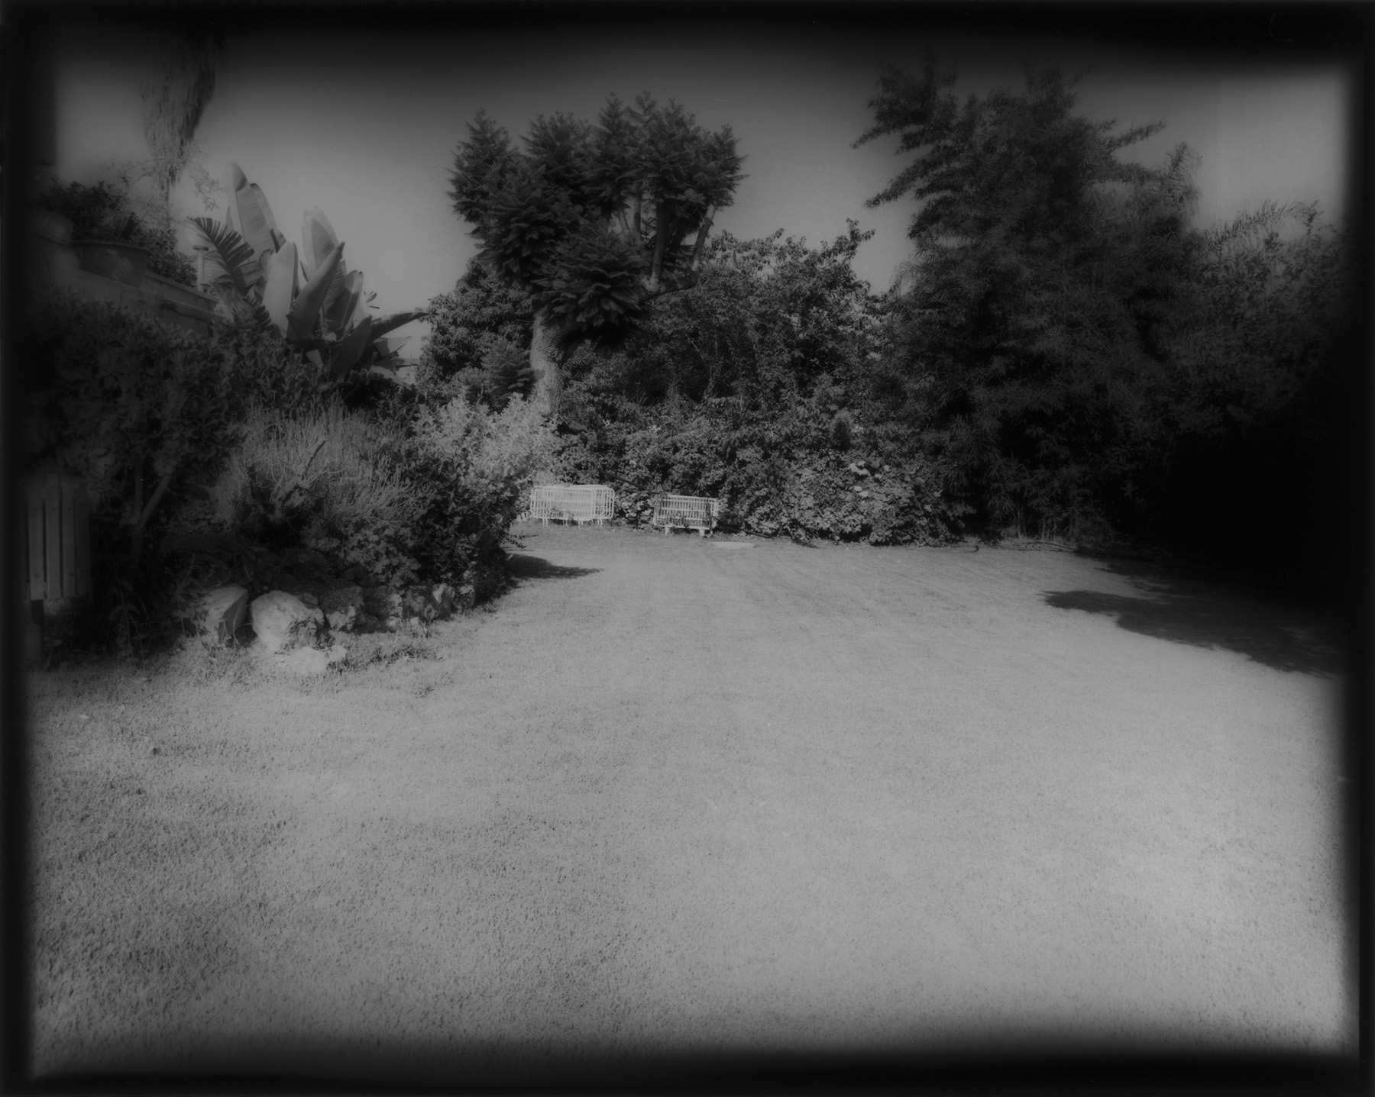 | 