Gabriel Chifu
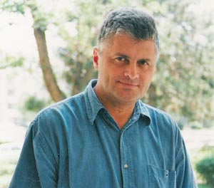
Biography

Gabriel Chifu (b. 1954) is currently chief editor of the literary magazine „Ramuri“, published by the Romanian Writers’ Union. He published poetry, prose, articles and essays in most of the cultural magazines in Romania. In 1992, his poetry volume Angels and Gods, with an afterword by Richard Jackson, was published in the USA. Some of his poems were translated and published in various countries around the world. He was awarded several prizes for his writings, including the Debut Award of the Romanian Writers’ Union. Among his poetry books: A place in the Heart (debut, 1976); Endless Man (1987); The Golden Padlock (an anthology, 2004). Among his novels: Where the Eagles Rest (1987); The Marathon of the Vanquished (1997); An Authority Cartographer (2000); The Stories of Cesar Leofu (2002); The Dream of the Child Walking in the Snow Without Leaving Footprints or The Invisible. Detailed Description (2004).

Further details: http://www.uniuneascriitorilor.ro/Chifu%20CV.htm

