The Department of Social Theology cordially invites you to the
International Conference on the Holocaust: Diachronic and Interdisciplinary Approaches
3-5 of October 2017
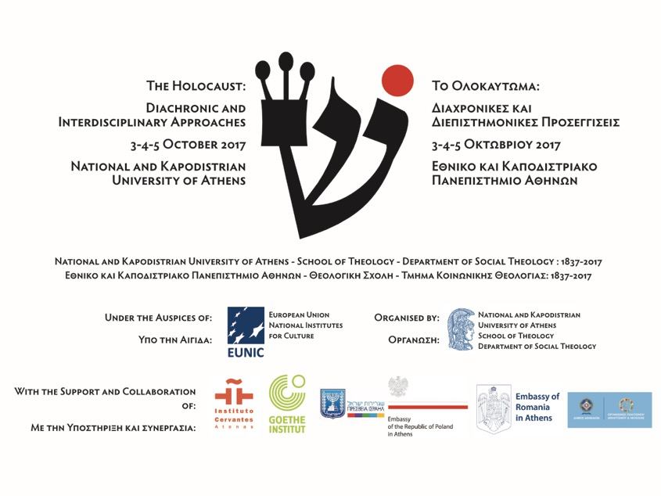
The Department of Social Theology, on the occasion of the official celebrations for the 180 years since the founding of the National and Kapodistrian University of Athens is organising an International Conference, “The Holocaust: Diachronic and Interdisciplinary Approaches”.

The action is under the auspices of EUNIC (European Union National Institutes for Culture) and is organised with the support and collaboration of Instituto Cervantes de Atenas, Goethe-Institut Athen, the Embassies of Israel, Poland and Romania in Athens. The screening at the Cultural Centre of the City of Athens is organised with the support of the Organisation for Culture, Sports and Youth of the City of Athens.

The Conference will take place at the following dates and locations:
3rd of October, 19:00, at Kostis Palamas Building (Akadimias 48)
4th of October, 10:30, at the Main Building of the National and Kapodistrian University of Athens (Panepistimiou 31)
4th of October, 20:30, free screening at the Cultural Centre of the City of Athens (Akadimias 50)
5th of October, 13:00, at the Goethe-Institut Amphitheatre (Omirou 14-16)

The official language of the Conference is English and the Department will distribute select translations of abstracts in Greek, as well as certificates of attendance to interested parties.
Full Programme of the Conference

Lectures – 3rd of October – Kostis Palamas Building – 19:00-21:00
Inaugural Speeches

- The Deputy Chief of Mission of the Embassy of Israel in Athens, Ms. Sawsan Hasson.
- The President of the Faculty of Social Theology, Professor Dr. Sotirios Despotis.
- The Deputy President of the Faculty of Social Theology, As. Professor Dr. Kirki Kefalea.

Lectures
- Dr. Michal Govrin, Writer, Director, Academic Chair of the Theater Department of The Emunah College, To Remember Responsibly: The Holocaust as an Ongoing Ethical Challenge. The Lesson of Jewish Ritual.
- Dr. Joel Zisenwine, Project Director at Yad Vashem, Transports to Extinction: Documenting Holocaust Era Deportations.

Inaugural Speeches and 1st Panel – 4th of October – University of Athens Main Building – 10:30-14:00

Inaugural Speeches
- The Rector of the National and Kapodistrian University of Athens, Professor Dr. Meletios-Athanasios Demopoulos.
- The Special Secretary for Religious and Cultural Diplomacy at the Greek Ministry of Foreign Affairs and Head of the Greek Delegation at IHRA (International Holocaust Remembrance Alliance), Dr. Efstathios C. Lianos Liantis.
- The President of the Athens EUNIC (European Union National Institutes of Culture) Cluster, Director of Goethe-Institut Athen and Regional Director of the Goethe-Institutes in Southeastern Europe, Dr. Matthias Makowski.
- The Dean of the School of Theology of the National and Kapodistrian University of Athens, Professor Dr. Apostolos Nikolaides.

1st Panel: Sacrifice, subversion and persecution: historical perspectives from the Second Temple Period / Hellenistic Era until the Middle Ages

- Dr. Pablo A. Torijano, Professor at the Department of Hebrew and Aramaic Studies – Complutense University of Madrid, Jewish communities in Late Antiquity: judeophobia and hybrid identity.
- Dr. Konstantinos Zarras, Associate Professor at the Faculty of Theology, University of Athens, Job as Israel – Israel as Job in Saadiah Gaon.
- Dr. Ioannis Konstantakos, Associate Professor at the Faculty of Philology, University of Athens, Daniel’s Holocausts: Persecution and the theological transformation of the Near-Eastern courtly novella.
- Anastasia Loudarou, Jewish Museum of Greece Researcher, Archaeologist, M.Sc., Ph.D. candidate in Ancient History, Aristotle University of Thessaloniki, Judaism in the Graeco-Roman World: A society in conflict? Jews, Samaritans, Greeks and Romans in the island of Delos (2nd c. BCE -1st c. BCE).
- Dr. Sotirios Despotis, Professor at the Faculty of Social Theology, University of Athens & Dr. Panagiotis Stamatopoulos, Postdoctoral Research Fellow at the University of Athens, From the Maccabees to Early Christians: the witness as martyr.

Discussion and Free Film Screening – 4th of October – Cultural Centre – 20:30

Presentation (in Greek): Jewish Communities in Greece
- Soultana Zorpidou, archaeologist – culturologist, intercultural communication advisor, “The lost Jewish community of Kastoria in the past and the future”.
- Theocharis N. Vadivoulis, lawyer – graphologist, “The Jewish community of Arta: History and Memory”.
Free Screening
THE INTERROGATION – directed by Erez Pery (2016, Israel – Germany, 84′, Greek and English subtitles). Based on the autobiography of Auschwitz commander Rudolf Höss. In 1946, Rudolf Franz Ferdinand Höss, the longest serving commander of Auschwitz concentration camp, is awaiting trial in a Polish prison. Albert, a young and successful Polish investigation judge, is appointed to interrogate Höss and get a perfect confession out of him. The encounter between the two men will unveil the frightening routine and banalization of evil that took place in the camp. By introducing the use of Zyklon B in Auschwitz, Rudolf Höss carried out the most efficient mass killing process ever known, which claimed the lives of approximately 1.1 million people. The film is based on the memoirs Höss wrote before his execution.
The screening is free to the public. With the support of the Organisation for Culture, Youth and Sports of the City of Athens.

2nd Panel – 5th of October – Goethe-Institut – 13:00-15:00
The Holocaust: Historical, Political and Social Approaches with an emphasis on Greece.

- Dr. Wolfgang Benz, Professor Emeritus – Technische Universität Berlin, Ideology and the human dimension of experience: The Jews of Rhodes as paradigm.
- Dr. Simon Leader, Professor at The American College of Greece, The Holocaust and the Manchester Guardian 1942-43.
- Dr. Alexandra Patrikiou, Jewish Museum of Greece Researcher, Individual experiences of hiding places during the Shoah in Greece.
- Dr. Leon Saltiel, Postdoctoral Fellow, Graduate Institute of International and Development Studies, Geneva, Efforts in Athens to save the Jews of Thessaloniki during the Holocaust.
- Dr. Paul Isaac Hagouel, member of the Academic Working Group of the Greek Delegation to the IHRA and Member of the Committee on the Genocide of the Roma, The Jews of Thessaloniki: Legacies of the Past, Shaping of Traditions, Challenges for the Future.

3rd Panel – 5th of October – Goethe-Institut – 15:30-17:30
A Place and a Name: The Influence of the Holocaust in Literature and the Arts.

- Dr. Anca Tudorancea Ciuciu, Associated lecturer of Jewish History at the University of Bucharest and Scientific Secretary at the Centre for the History of Romanian Jewry of the Federation of Jewish Communities in Romania, Sighet and Elie Wiesel, before and after the Holocaust.
- Dr. Fragkiski Ampatzopoulou, Professor Emerita at the Aristotle University of Thessaloniki, Faculty of Philology – Modern Greek Literature, The Holocaust in modern Greek literature.
- Dr. Maria Komninou, Professor at the University of Athens – Faculty of Mass Media and Communication, The Holocaust on film.
- Dr. Nikolaos Mathioudakis, Academic advisor at Kazantzakis Publications and Professor at the Karolos Koun Drama School, The Holocaust in Theatre.

4th Panel – 5th of October – Goethe-Institut – 18:00-19:30
The Trivialization of Evil and its Implication in Current Debate and Education.

- Mr. Andrzej Kacorzyk, ICEAH Director and Deputy Director of the Auschwitz-Birkenau State Museum, We are still not doing enough.
- Rabbi Gabriel Negrin, officiating at Beth Shalom Synagogue.
- Zanet Battinou, Archaeologist, Director of the Jewish Museum of Greece, Inspiring Active Citizens: The Role of the Jewish Museum of Greece in Holocaust Education.

Organised by 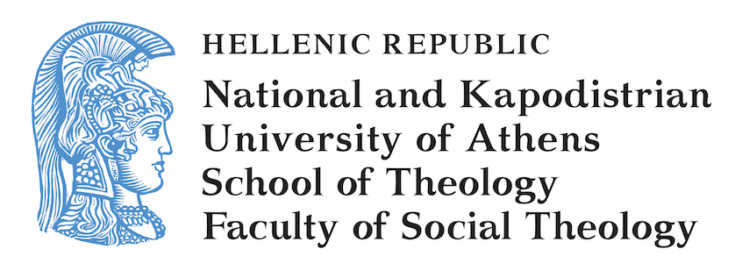Under the auspices of 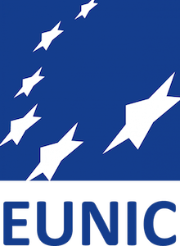

With the support and collaboration of
